**Joe Stewart –interaction designer**

* 1. **What type of companies have they worked for? Or, what types of companies do they have as clients?**He currently own a digital product design company, Work&Co. He used to work as an interaction designer. He worked at Huge for 7 years before he co-founded Work&Co. His client includes Target, MoMA store, Reuters , jetBlueVirgin America, Youtube,etc. Now his client include NBA, Google, Youtube, Virgin America,etc.
  2. **Where did they learn how to do their job? How many years of experience do they have?**As he described in the interview, as an interaction designer, you have to learn every 2 years. He worked at Huge for 7 years, then he co-founded Work&Co at 2013, which means he worked at Work&Co for 2 years now. He has 18 years of digital experiences.
  3. **What are the skills they use every day?**He uses Quartz Composer and Form to see the design and the scale in prototype, he so user testing while he is not sure which prototype is better. Prototype is the skill he used everyday, instead of making presentation to his client.
  4. **What software or programming languages do they know?**He uses program like, Marvel,Proto.io,Invision. He also used AfterEffect or Keynote when he wants to look for something quick and cheap.
  5. **Who are their mentors or influencers—people they admire?**He is influence by the design works of BRAUN, design work of Peter Saville. He loves to take photo and post them on his VSCO page. He is also influence under the Todd Purgason at JUXT Interactive.

**3 projects**

[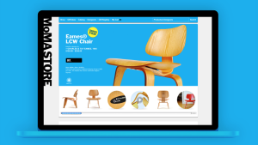](http://parsons.ojusdoshi.com/wp-content/uploads/2015/09/Screen-Shot-2015-09-08-at-9.58.16-PM.png)

[MoMA Store](http://www.allcaps.cc/#)

I think the design for the MoMA store is clever, I like how everything is very straight forward. It is good to look at. The object are the center of the page, unlike many other commercial good website. The image of the product has to zoom in to see the detail. This design highlight the detail, also brings customers a artistic experience while using the website

[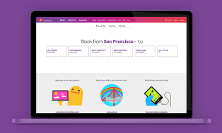](http://parsons.ojusdoshi.com/wp-content/uploads/2015/09/Screen-Shot-2015-09-08-at-10.49.29-PM.png)

[Virgin America](https://www.virginamerica.com/?cid=PS_gaw_BK_BNDEWR_2012_12_07&psmid=sA30yi03r%7Cdc_pcrid_80334496990_pkw_virgin%20america_pmt_e&psag=Virgin%20America%20-%20Exact&psaid=e&gclid=Cj0KEQjwjrqvBRD6wf2fy-C61PIBEiQAUzKQTh-jAAg9FoJuiDX09E8vv9Zq3mgCl2fL6UKD8ugqtuMaAmzy8P8HAQ)

I enjoy the website because it is easy to use with big font and reminder bar on the top, also the color usage is coherent with the brand image. The interaction design guide you through each steps, from selecting date to Flight. Very friendly to use.

[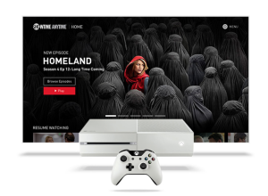](http://parsons.ojusdoshi.com/wp-content/uploads/2015/09/Screen-Shot-2015-09-08-at-11.03.31-PM.png)

[Showtime-Xbox 1](http://www.xbox.com/en-US/entertainment/xbox-one/live-apps/showtime)

I like the white text against the black background, it gives people a professional look. The minimal text also help with the user experience. Again the new platform is easy to use and right to the point.  As it is described, new platform results included increases in usage, content discovery, and subscriber loyalty.